- The “Create Contract” button under “All contract” and “My Contract” does not work 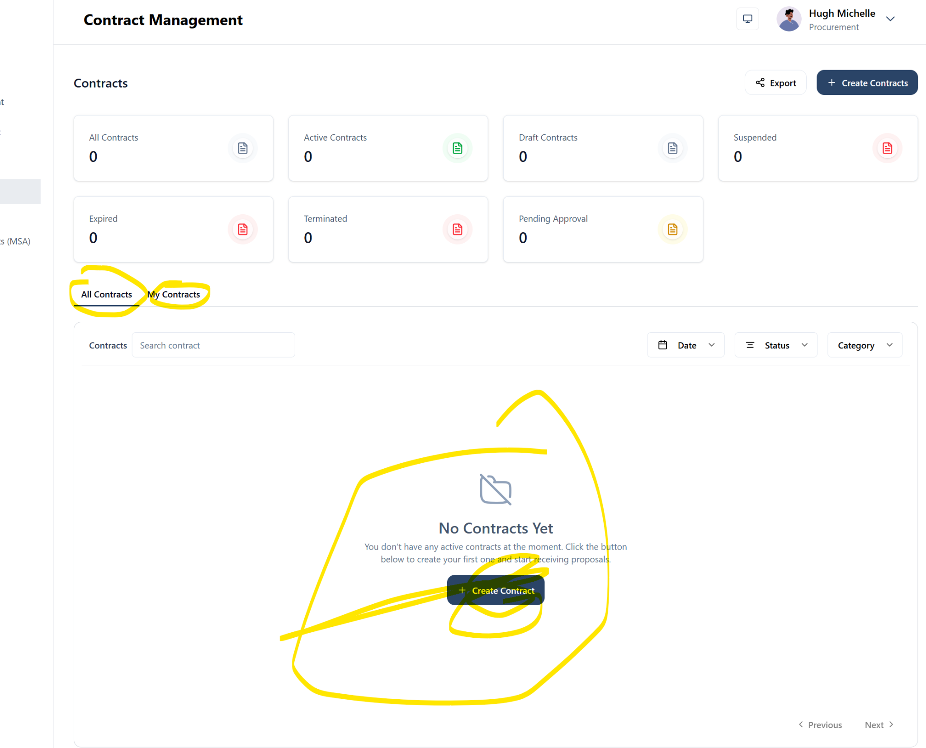
- Please add “Others” to the category.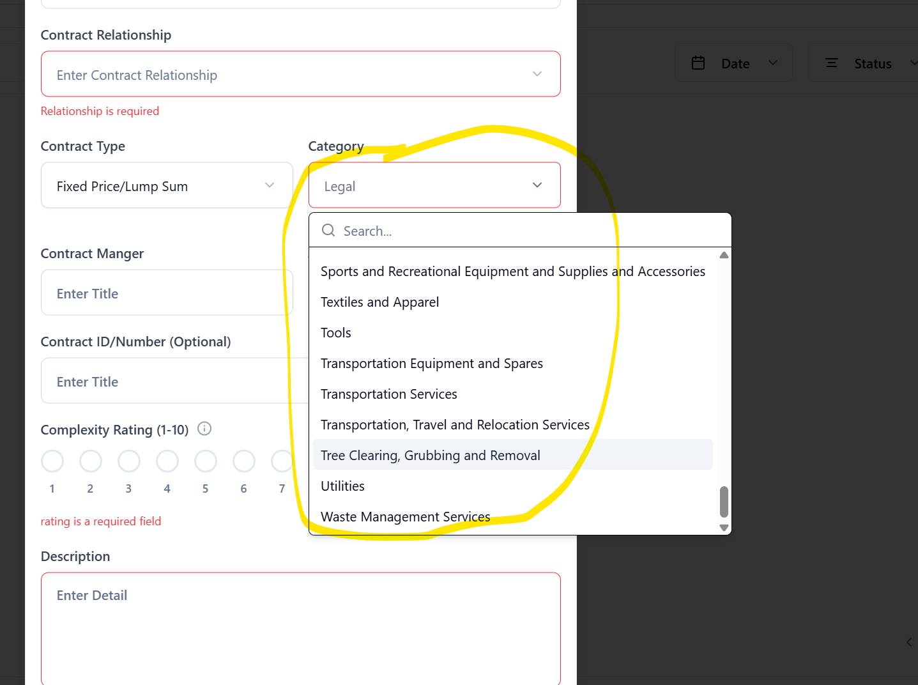

- Creating a CM profile - email reads they were invited as a Vendor. Please we cant have this kind of error at this stage. Otherwise testing will drag on for too long.
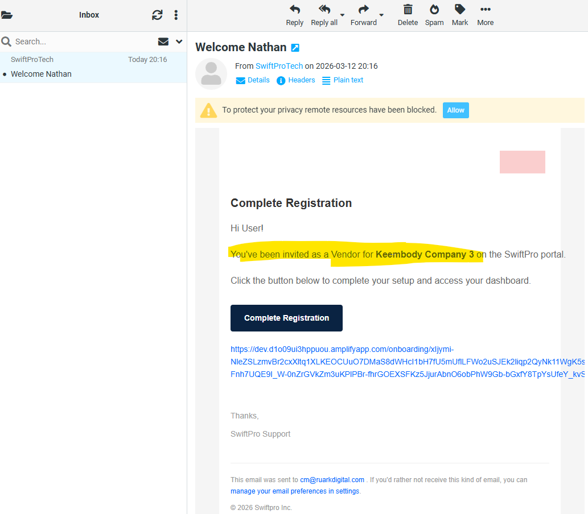
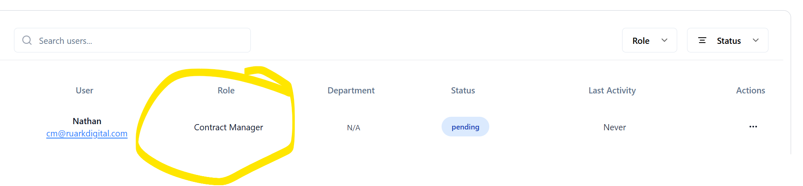

- Edit Business Division Coy Admin Profile - the edit button is not working
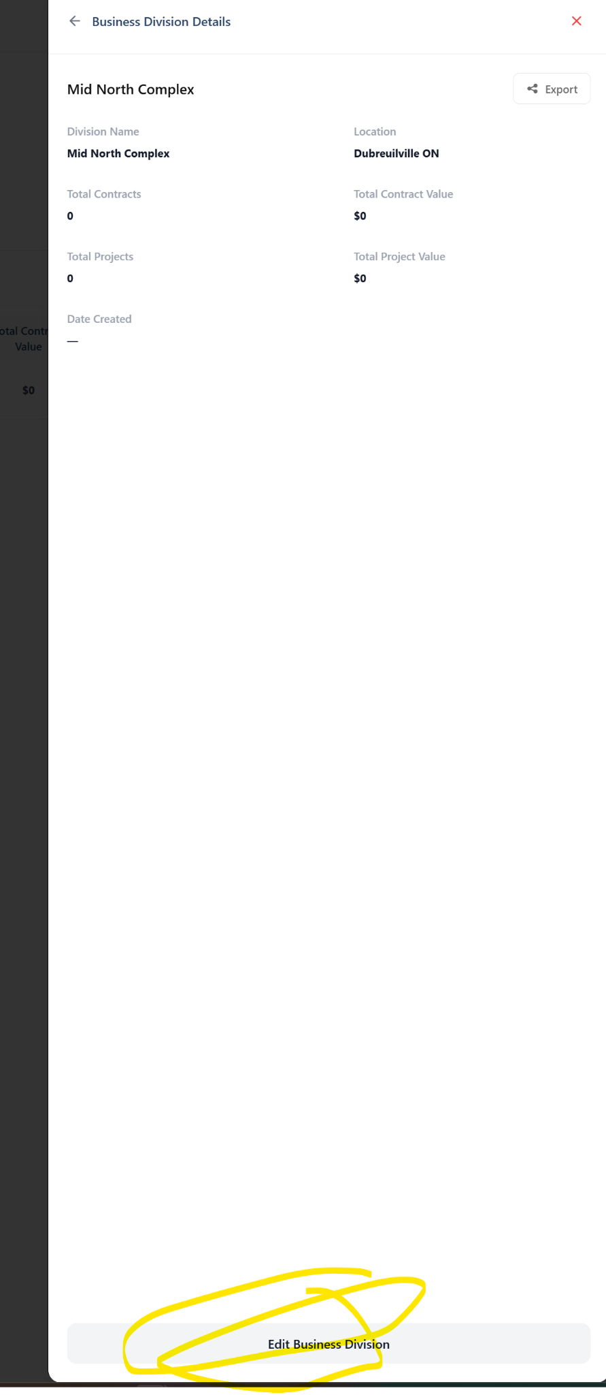
- Contract creation - Due Date for deliverable has a text “Side Visits/Conference call - Please remove
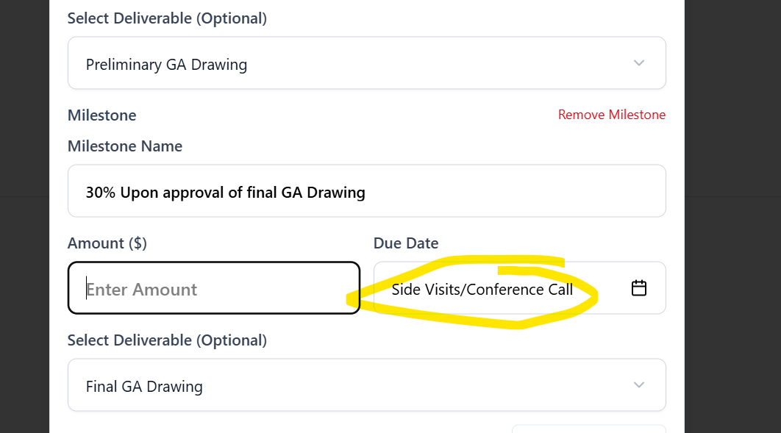

- CM Dashboard - Analytics - Vendor names under Contract value by vendor are clustered/mixed up please fix

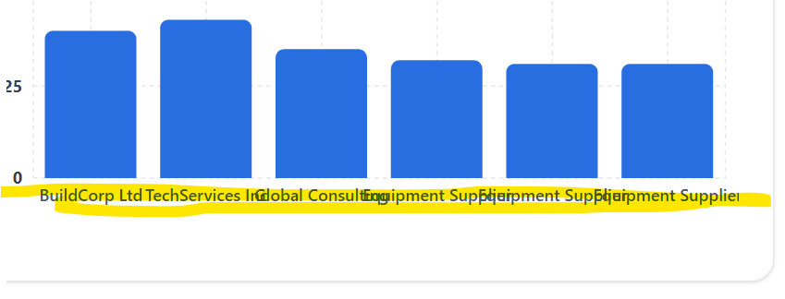
- Unable to save contract as draft after getting the approver selection stage

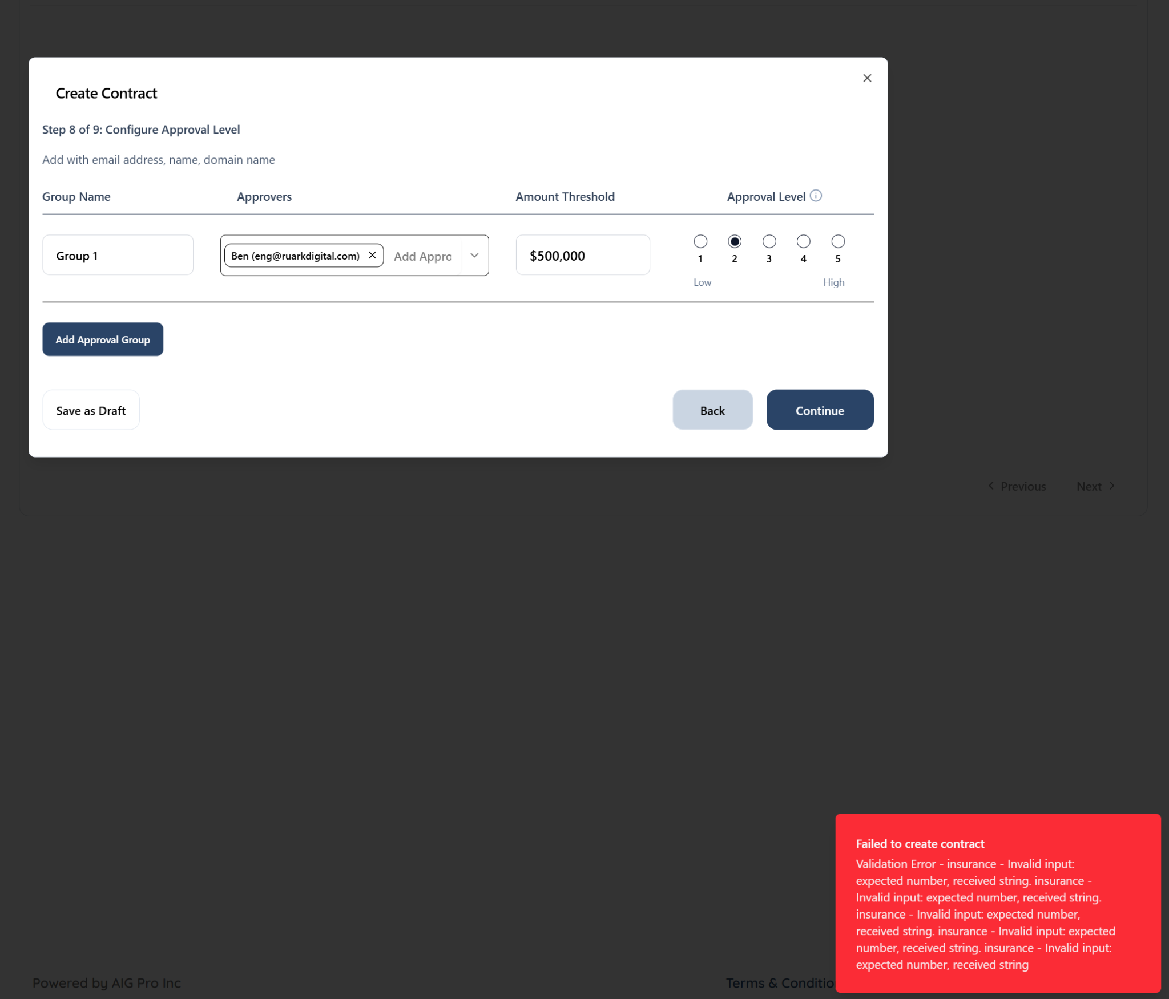

- Approver Profile - Dashboard - Analytics is missing: Please add Analytics.
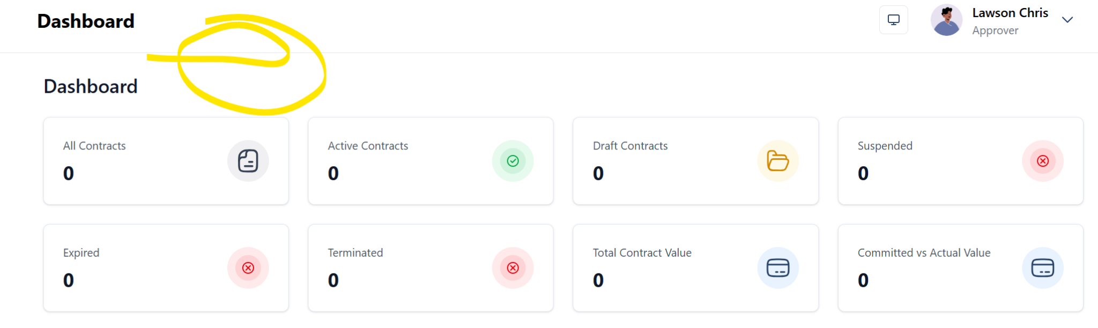
- Approver Profile - “Create Contract” is available - Please remove
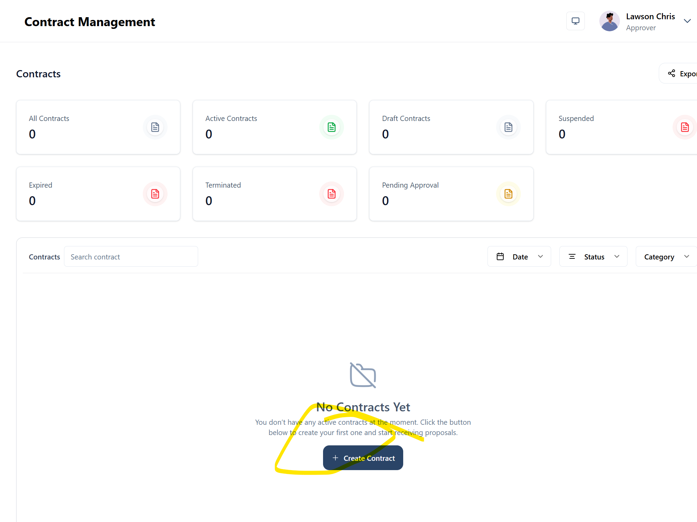

- Approver profile - Create MSA is available - Please remove
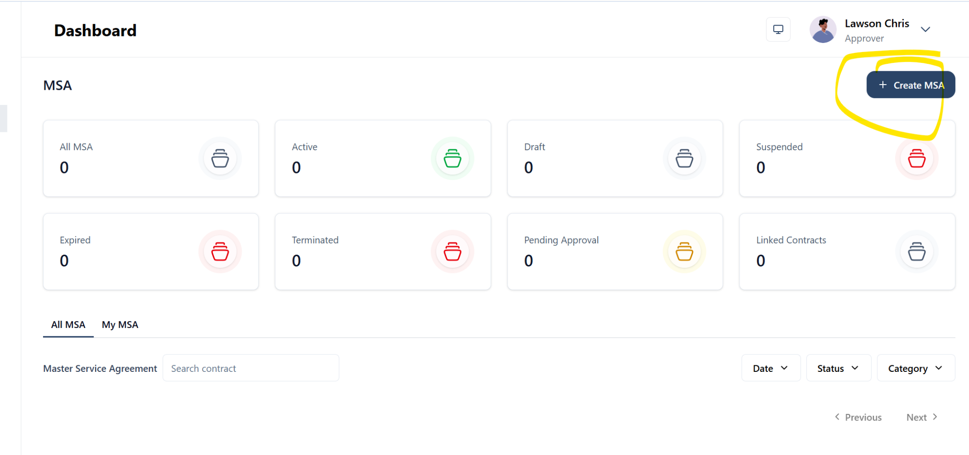

- Discrepancy with time - unfortunately the time issues has not fully disappear - see the confirmation in this email showing 9:15pm instead of 5:15pm - the time should be based on the local time of the user
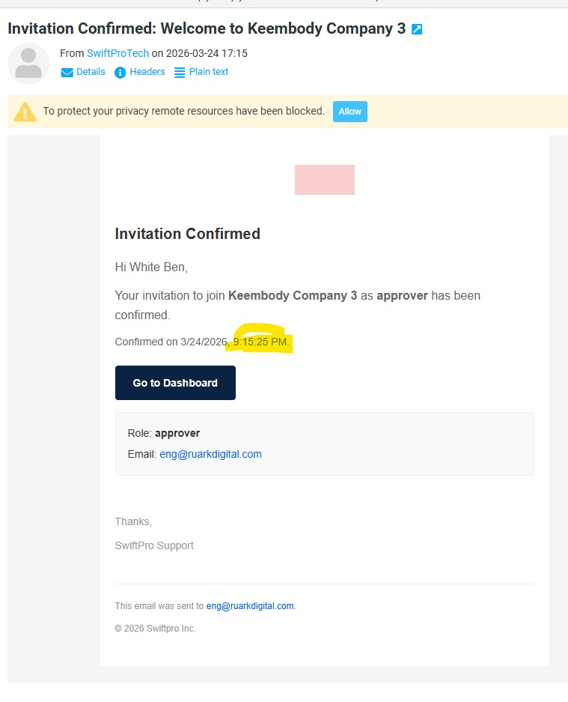
- Create Contract - Preview - Contract team - Vendor is showing random numbers and contract manager says not specified
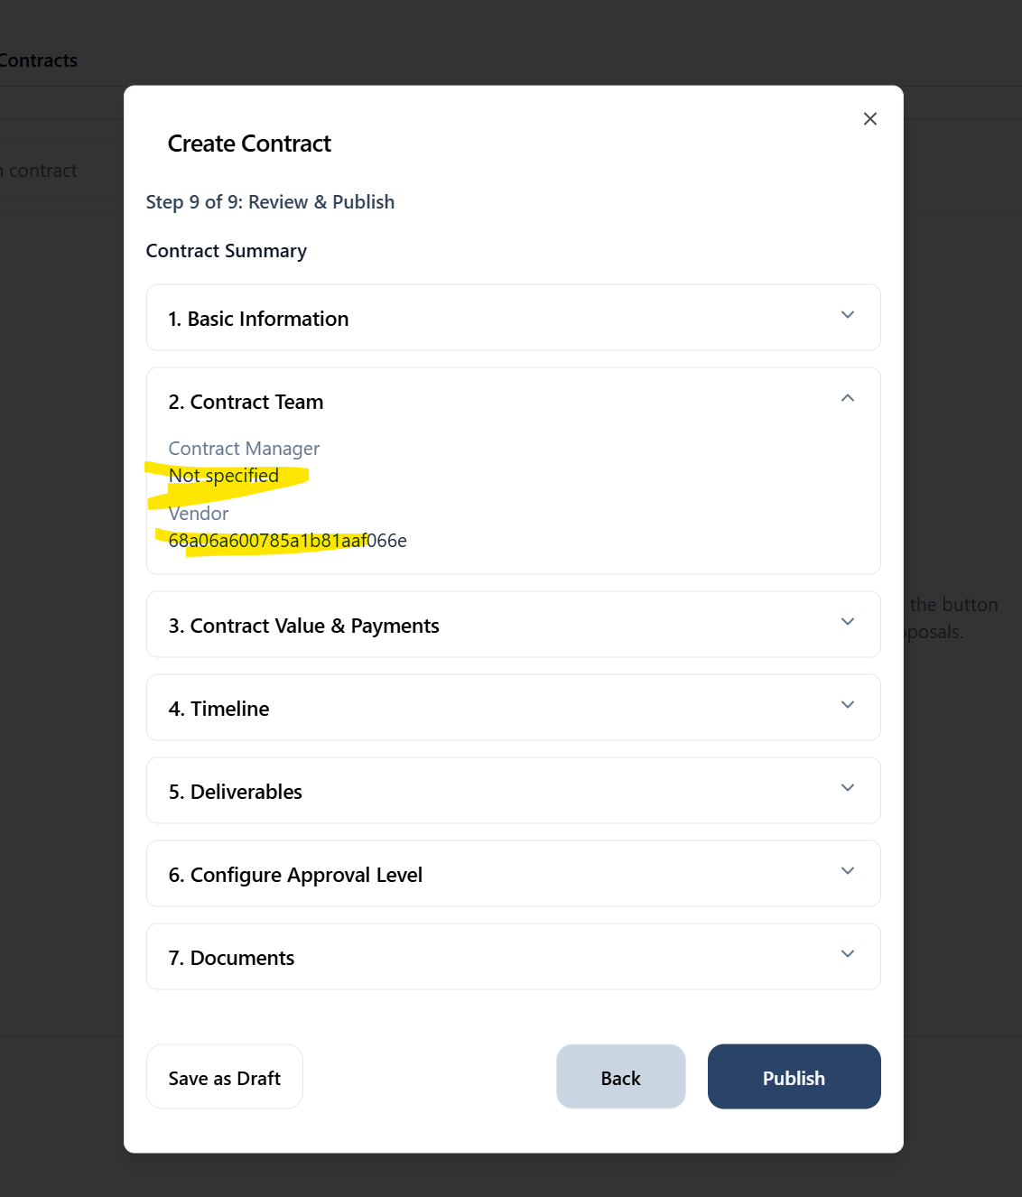
- Payment Milestone - I was able to go to the next stage without adding the amount and due date - the system should flag this - please fix
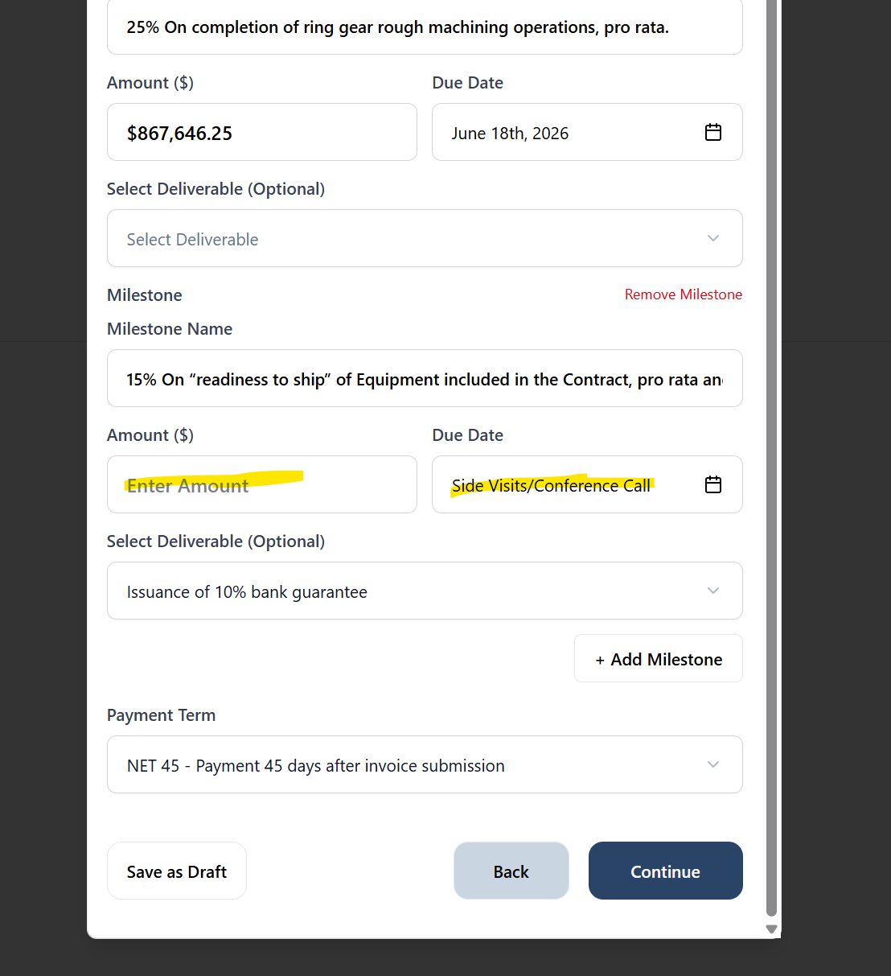

- Contract Type and Category showing random numbers
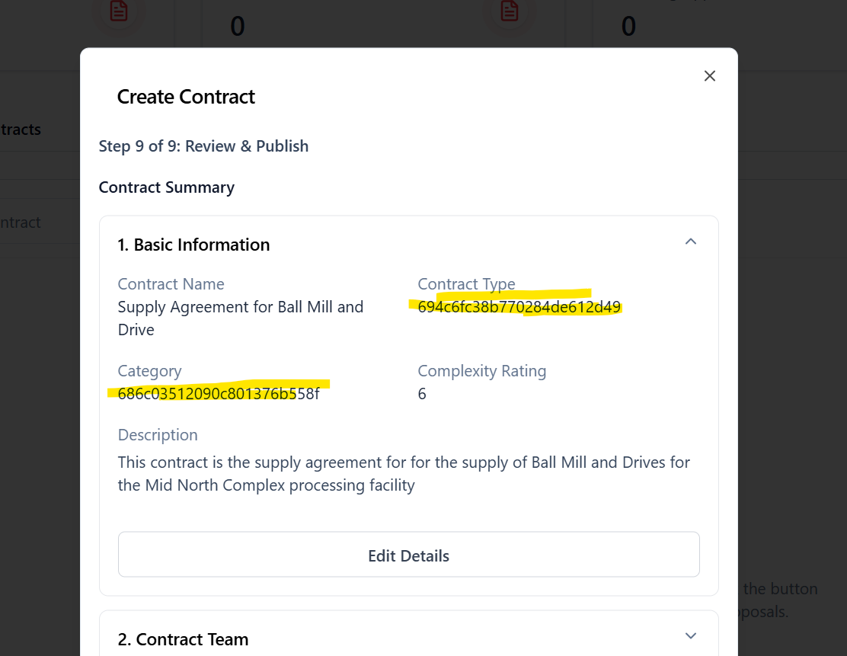

- Payment term is showing random numbers, the arrangement of the payment milestones needs paragraph and labelling- 1, 2 ,3, …etc…
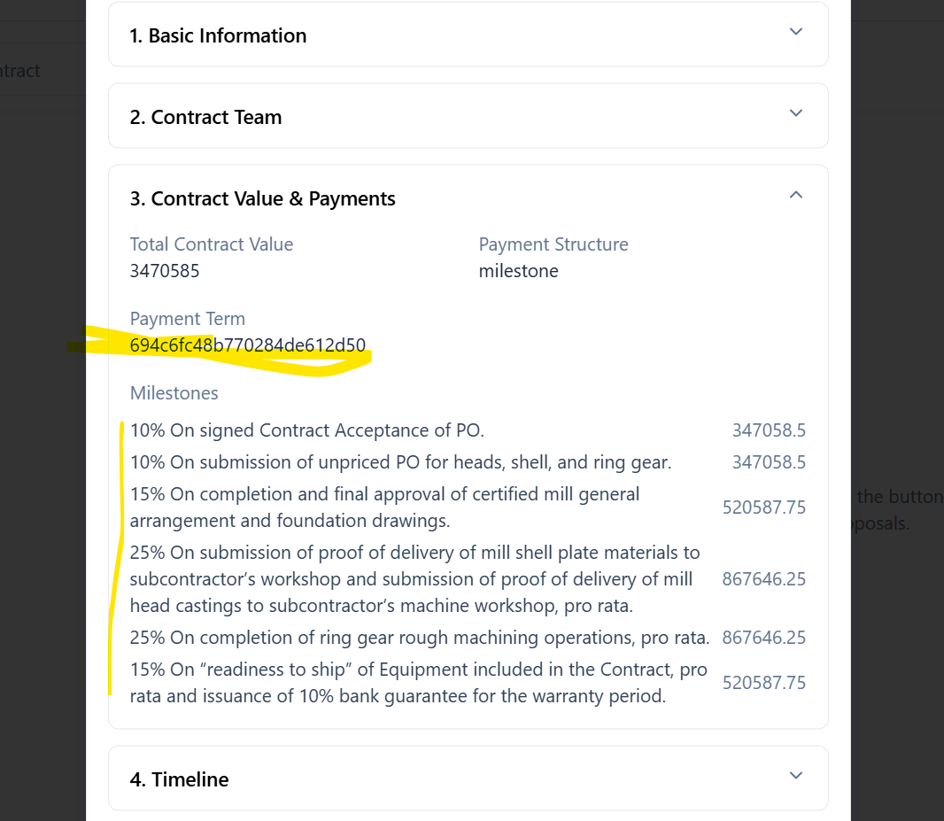

- General Updates - Multiple lines showing for the same update - please reduce to just 1
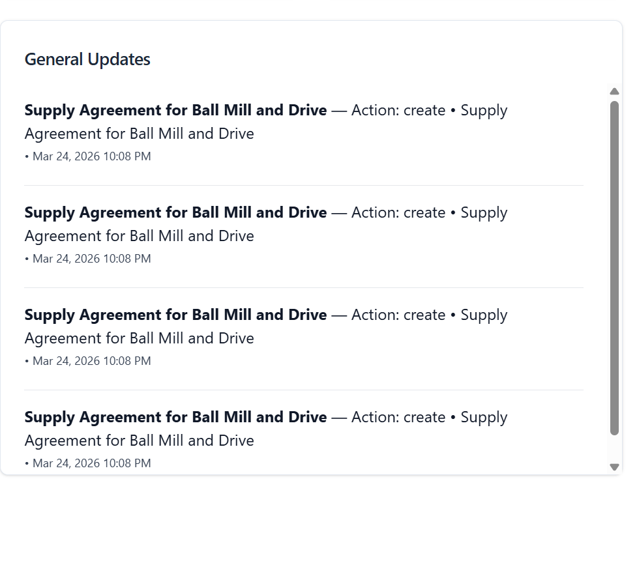

- Dashboard - Analytics - Portfolio level - unable to use All filters (YTD, 12 months, etc…They are not clickable
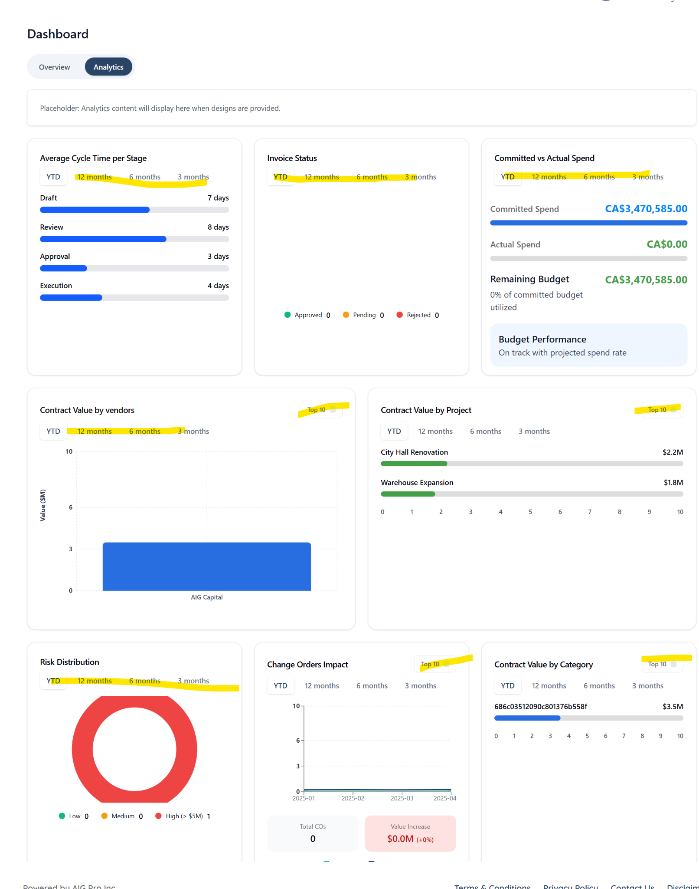

- Approvers - These folks were assigned as approvers for the initial contract approval - but the assigned approvals tab under approval show 0/0

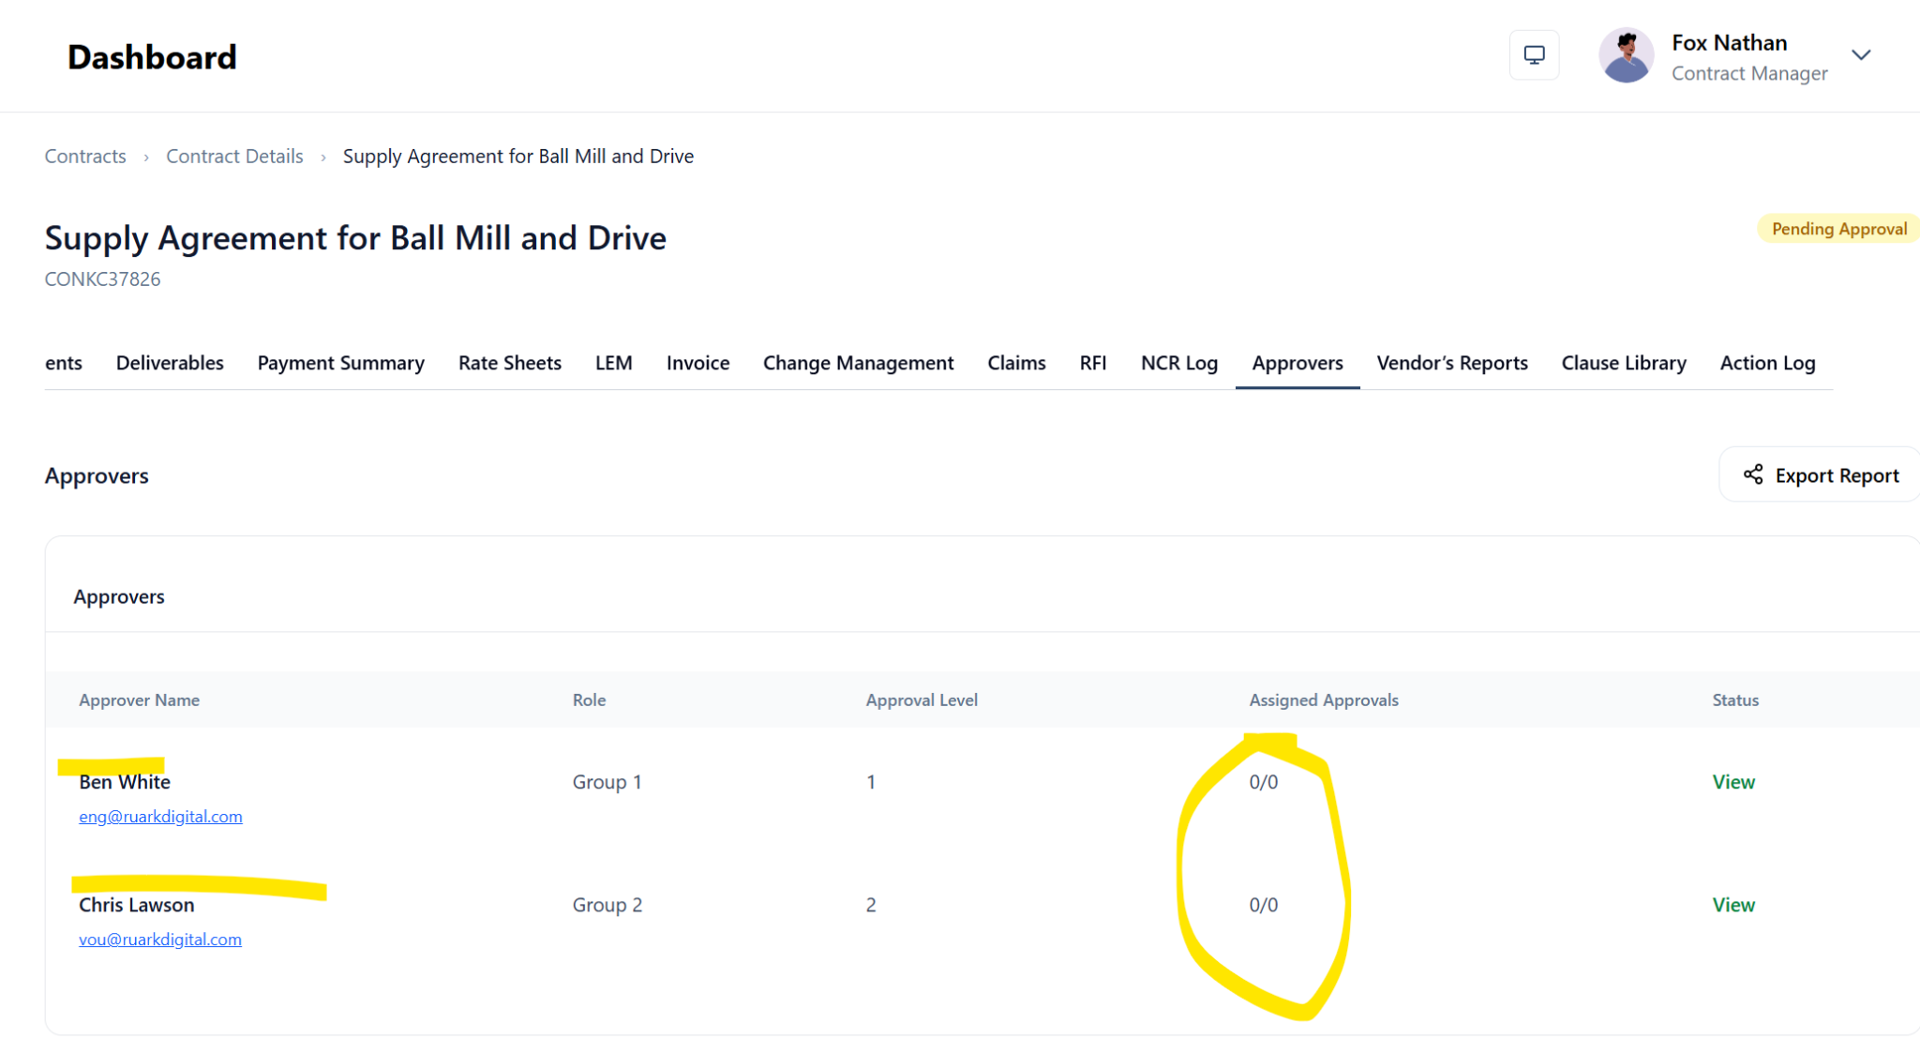

- Action log - lots of unknown - Please add more description. Uncertain what the last three actions are given this is a new contract
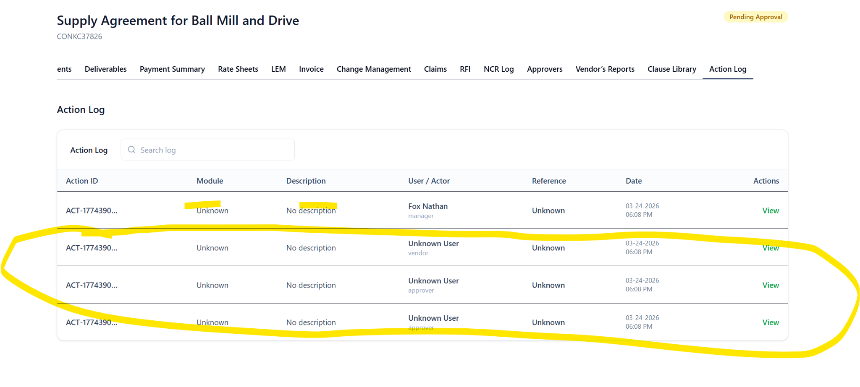

- Approver Dashboard - there is nothing under “My action” - there should be an action to proceed with contract approval.
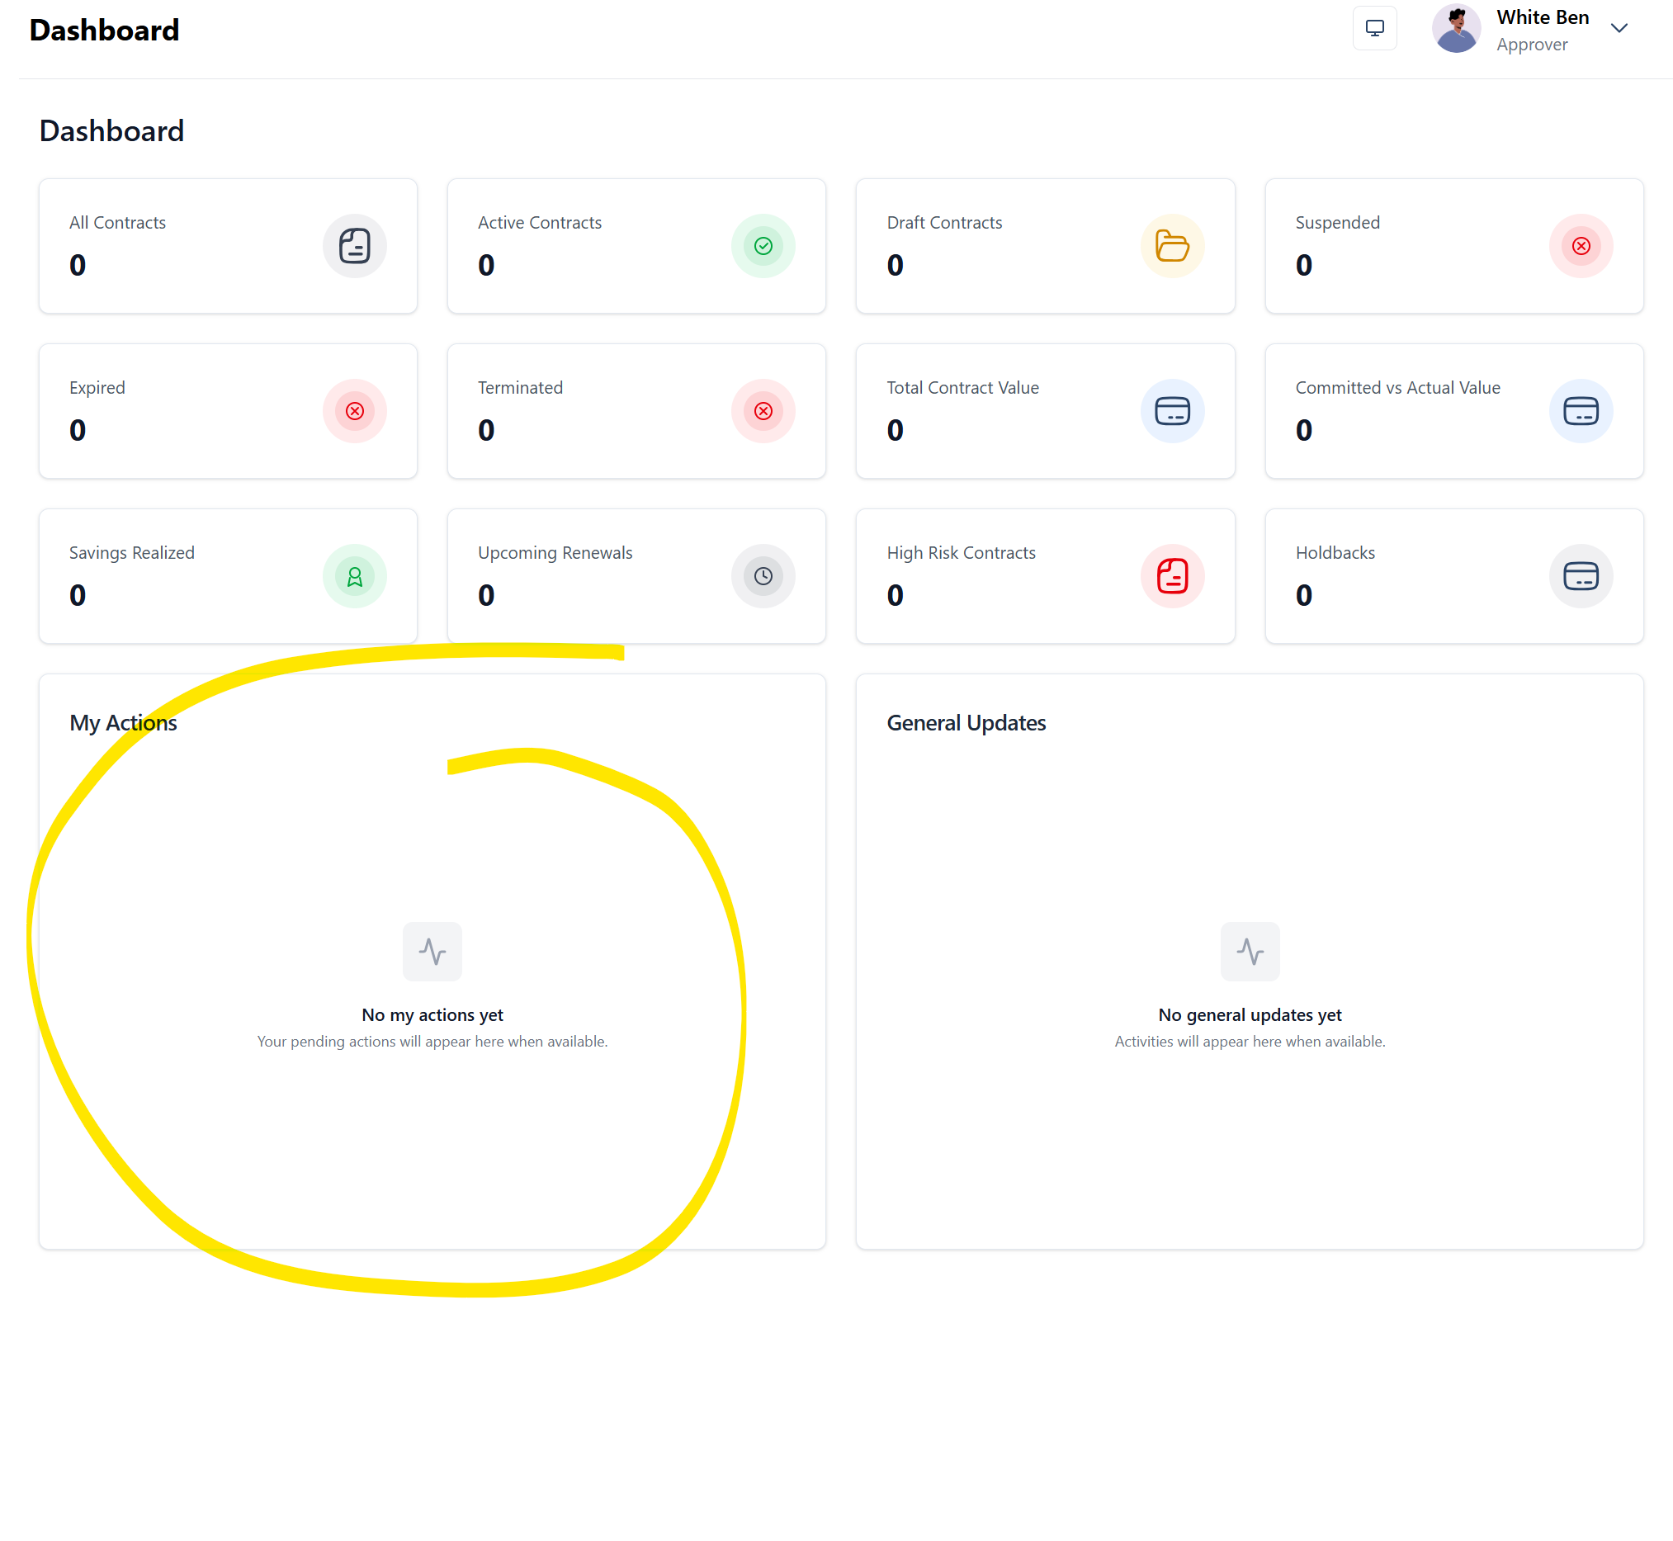
- Approver email notice - There is no email notice to approver prompting them to proceed with approval of the contract.

- Majority to all of the informations are not retained when you try to edit the contract please fix
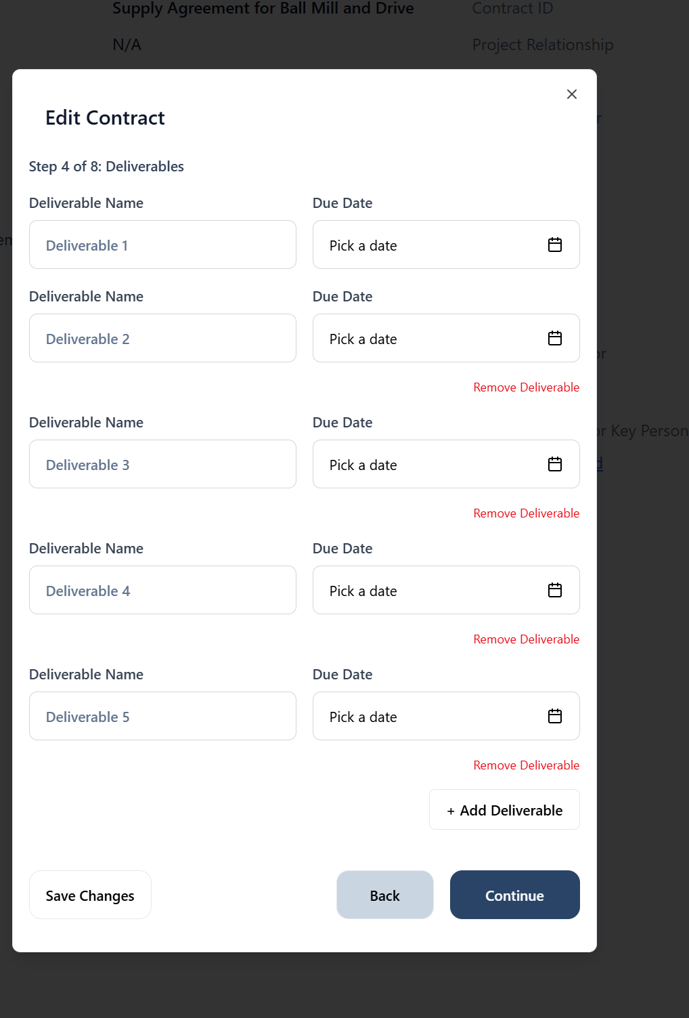
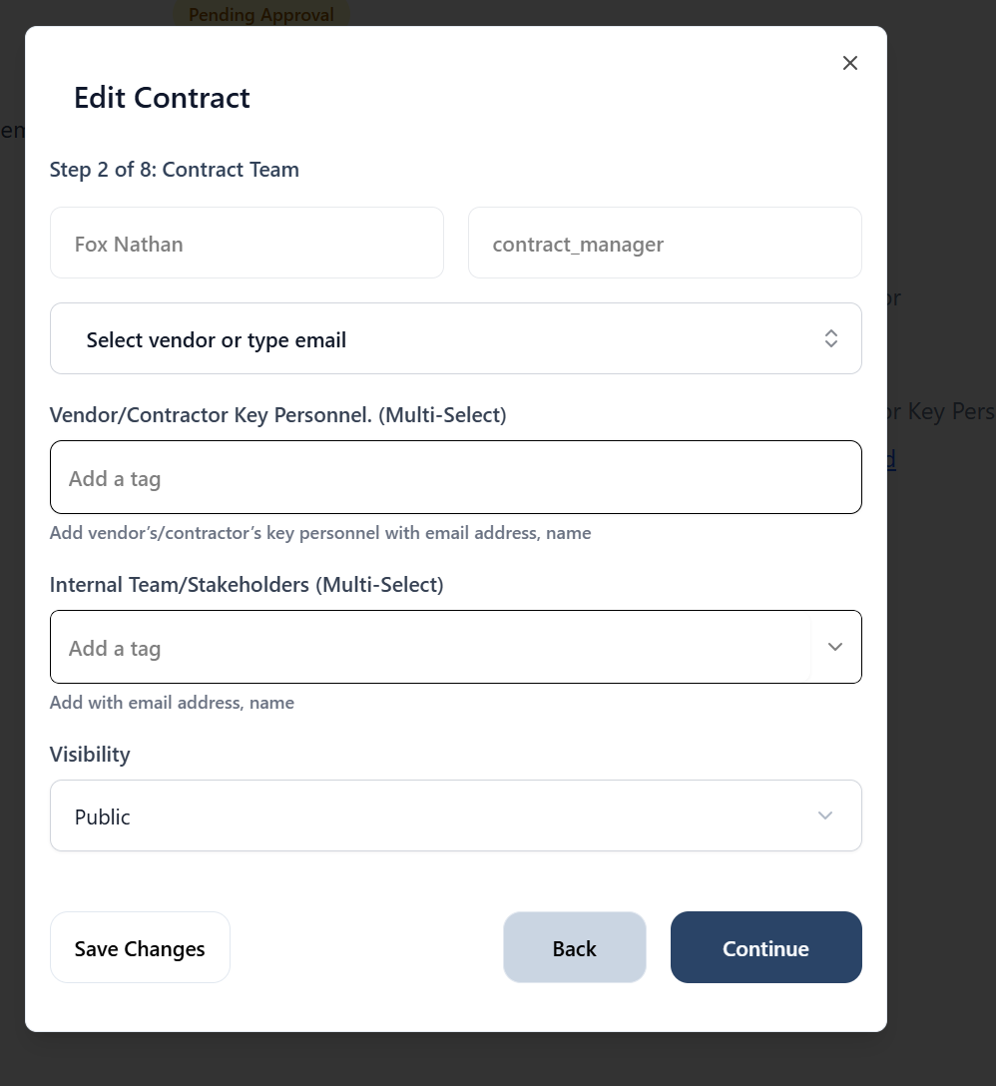
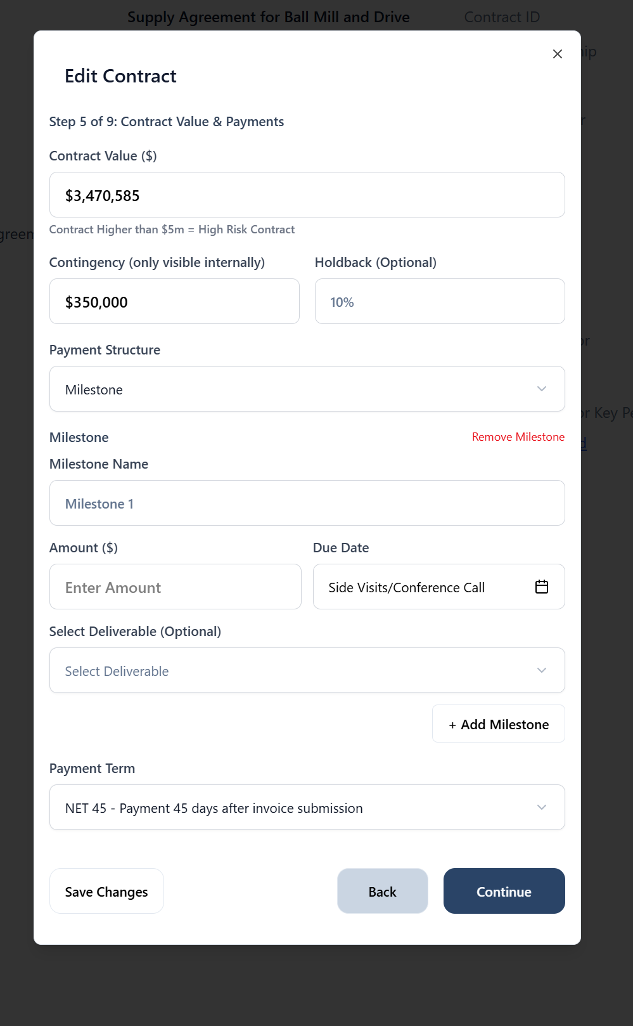
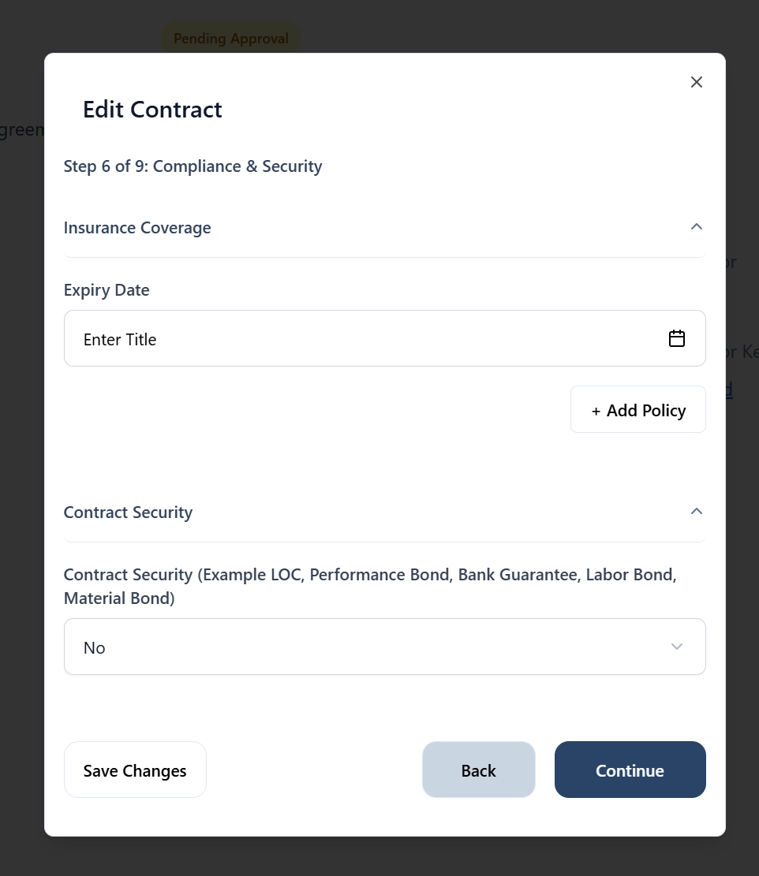

Then error message after step 6
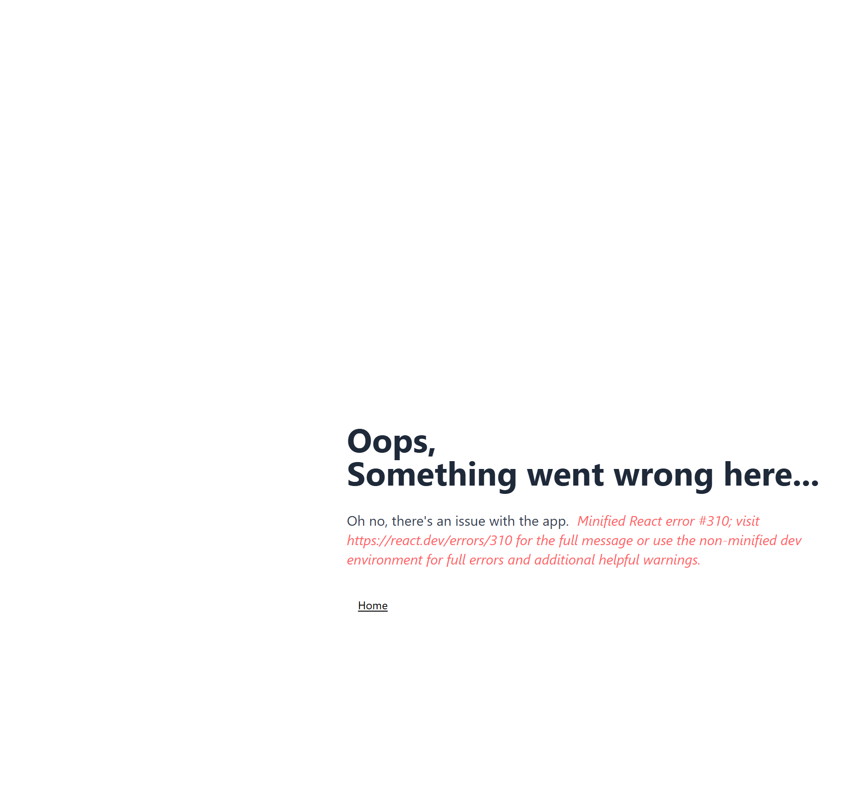

- Contract analytics - The Activities chat needs work - the months axis is not accurate.
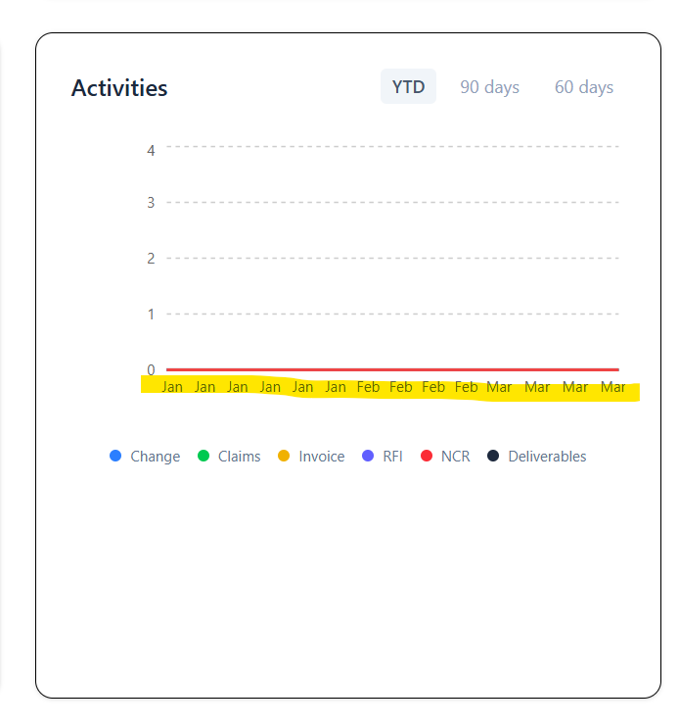
- Dashboard for approver and vendor is not showing number of contracts…currently 0 when there is one. Value is not showing as well.

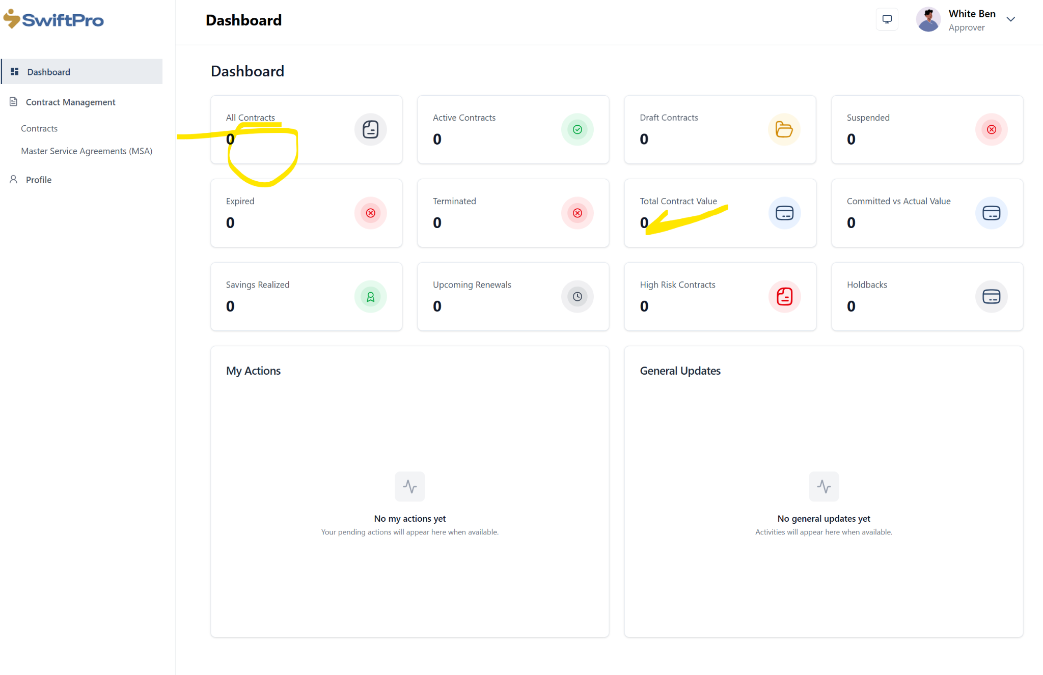
- Minor modification - Savings realized - please add “s”
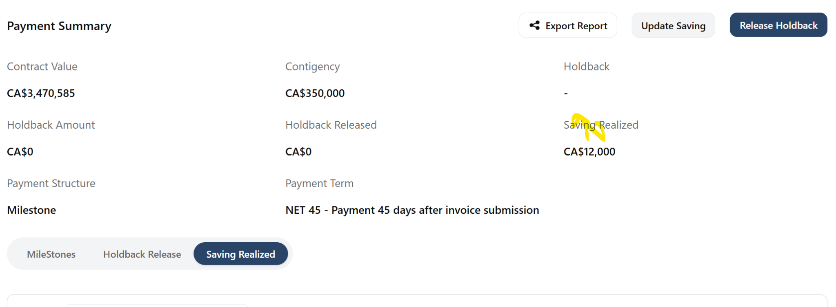

- Vendor and possibly other profiles - Deliverable status - all deliverables are pending but the status is “Under Review” please fix.
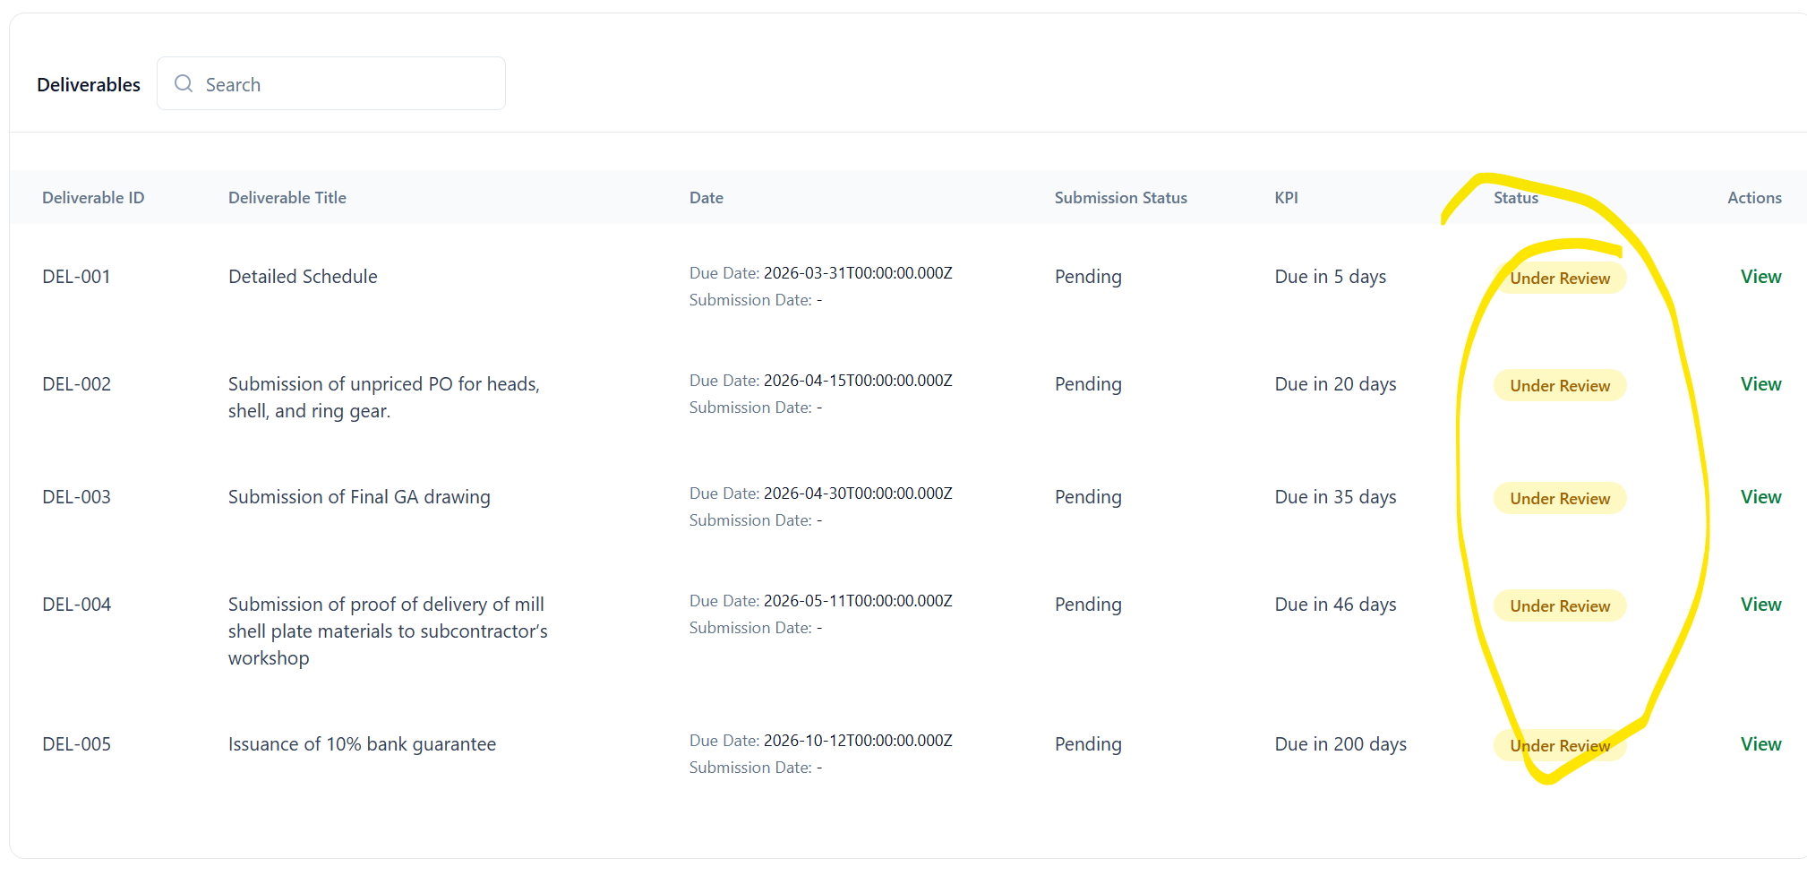
- Invoice creation - description - text space shows “Duration” please remove
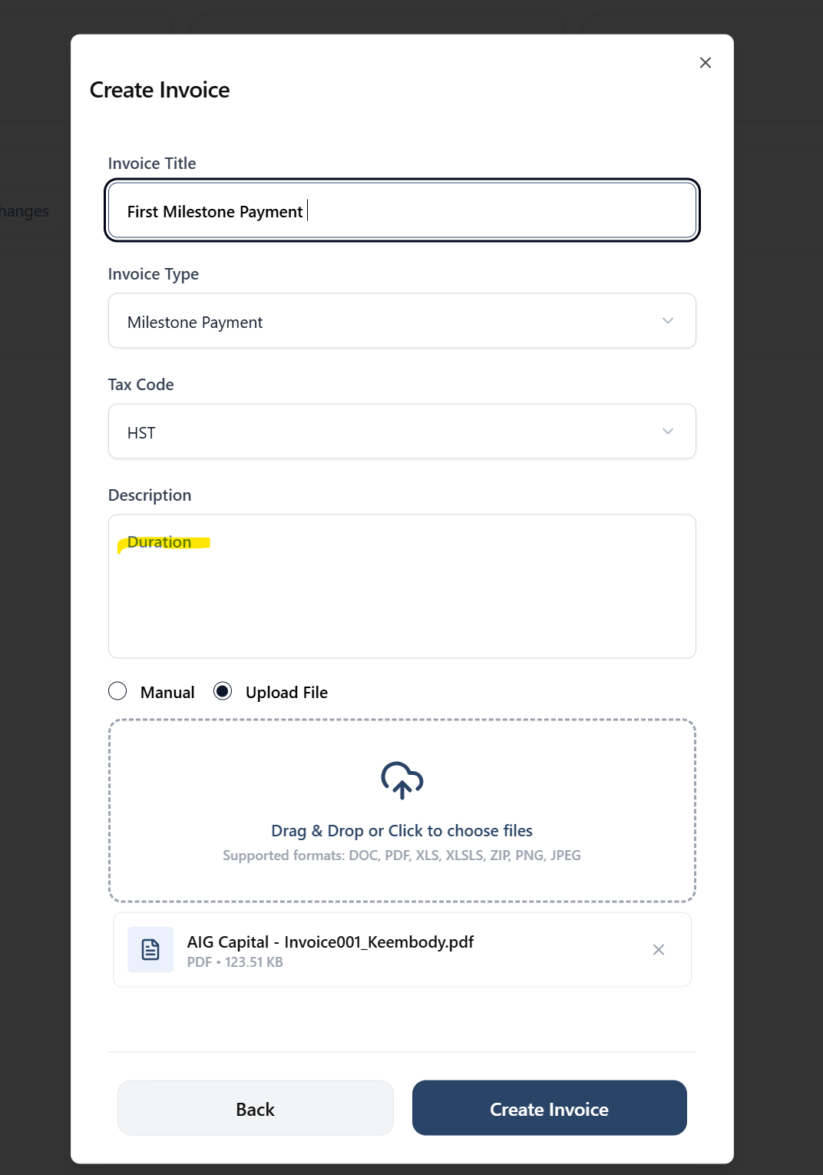

- Creation of Invoice - Invoice amount is not capture when the “upload file option is used…Do we need to add a field for the invoice amount? Or is the system supposed to capture the invoice amount from the attachment?
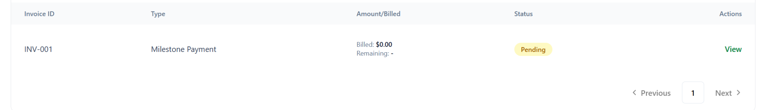
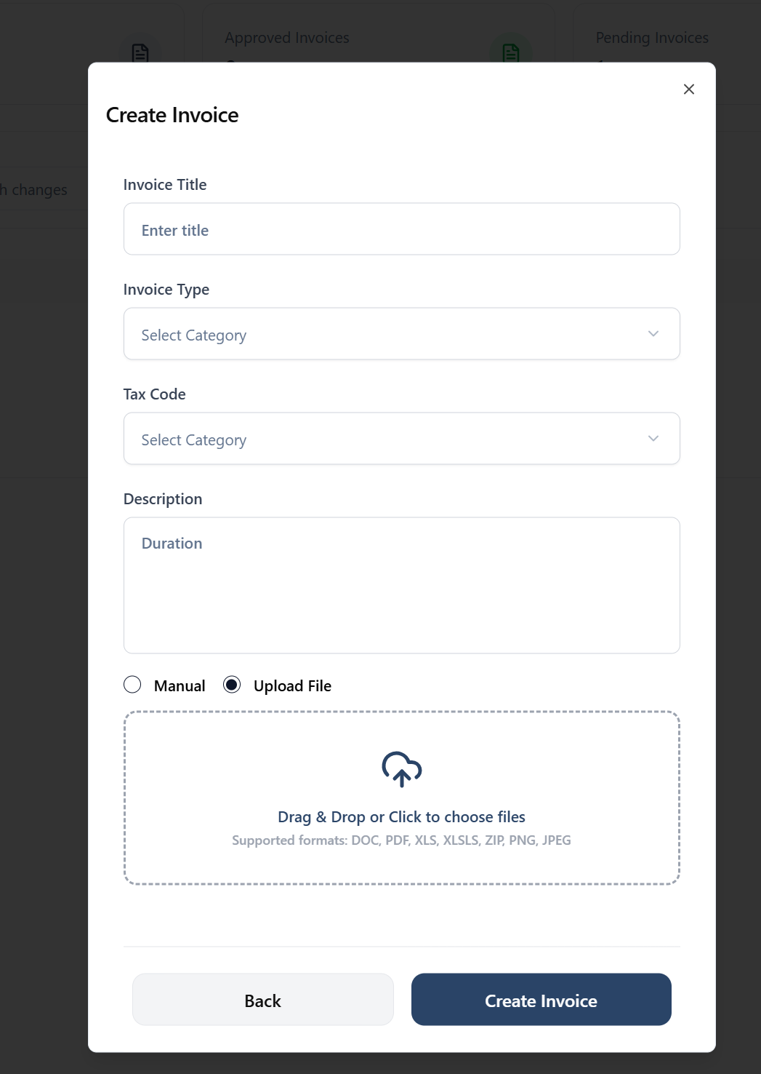

- CM profile - Invoice approval and rejection button is missing - please fix.
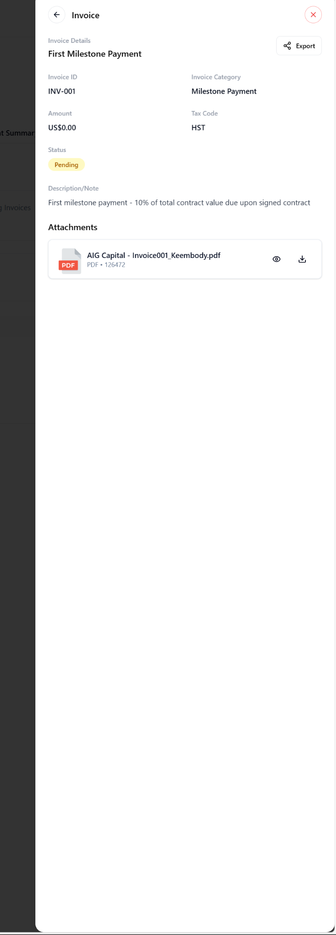
- Deliverables - Vendor side - this has Approve and reject instead of submit -please fix.
